Write in Scheme a recursive function er, and a non-recursive (based on do-loop) function ei,that take as their argument the number of components n, and compute the following sum(approximation of e)1 + 1/1! + 1/2! + 1/3! + ... + 1/n!, n>0

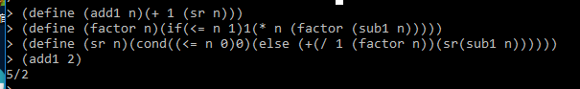

Write a Scheme program for print-plot of function f(x) = 15|sin(0.2x)|



Define the function f that returns f(x)Define the function xlist(n) the returns the list (1 2 3 ... n)

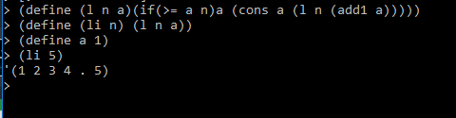

Define the function ylist(n) that returns the list (f(1) f(2) f(3) ... f(n)

Define the function point(y) that displays a line with max(0, y-1) spaces followed by '*'

Define the function graph(lst) which uses the function point to plot one line with point for each value of

the list lst

Show how to plot f(1) f(2) f(3) ... f(30) as in the presented example

___________________________________________________________________________---

A prime number is a natural number greater than 1 that has no positive divisors other than 1 and itself.

Goldbach conjecture claims that each even number greater than 2 is a sum of two prime numbers.

Write a Ruby function prime?(n) that returns true if n is prime and false if not

Use prime?(n) to write a Ruby function primearray(n) that returns an array that

contains all the prime numbers that are less than n

**def** prime(n)

prime=***true***

i=2

**while** i<=n-1

number=n%i

puts"**#{**number**}**"

**if** number==0

prime =***false***

**end**

i+=1

**end**

**return** prime

**end**

Use primearray(n) write function goldbach(even) that returns two prime numbers

(prime1 and prime2) such that even = prime1 + prime2

Using goldbach(even) write a main program that prints that attached table

4 = 2 +2

6 = 3 + 3

8 = 3 + 5

10 = 3 + 7

12 = 5 + 7

...

24 = 5 + 19

and soo on...

Create a Ruby class Book1, each book is characterized by the instance variables

author and title. For this class create the initializer and the method show1

that displays the instance variables of the class Book1.

Create a Ruby class Book2 that inherits Book1 and adds a new instance variables

publisher and price. Write the following Book2 methods:

read2 that prompts the user and reads from the user all data for Book2

show2 that displays all the instance variables of class Book2

Write a main program that reads from the keyboard an array of 3 books (objs of

Book2) and then displays all of them using show2

What are first class objects and write a good example of it